Kohl Johnson

CST-321

01-05-2025

Memory Management

# Memory Management Unit

A memory management unit (MMU) is a piece of computer hardware that examines all memory references on a memory bus. From there, it translates these requests (virtual memory addresses) into physical addresses in the main memory. The MMU also works hand-in-hand with the Translation Lookaside Buffer (TLB) to map virtual memory to the physical memory addresses. The TLB acts like a cache and is used to reduce the time it takes for physical memory to be accessed. Depending on the type/model of CPU, the TLB can have multiple levels of TLB to avoid misses and keep memory latency as low as possible.

# Page Fault Handling

A page fault is an event in computers where a program attempts to access data or code not currently available in main memory. There are three main types of pages faults: Minor Page Fault, Major Page Fault, and Invalid Page Fault. A minor fault occurs when a page is in memory but not within the current process’ page table. A major fault occurs when the page is not in memory and must be brought over from a disc. Finally, an invalid page fault occurs when a process attempts to access an invalid memory address. To handle a page fault, we first detect it through a hardware interrupt. From there, the operating system checks if the page is present in secondary storage or if the memory is valid. If there is no space for the page the OS then decides which page is removed from memory to make room. Then, the required page is loaded, the mapping is updated, and the process restarts whenever a new fault is detected.

## Page Fault Handling Diagram

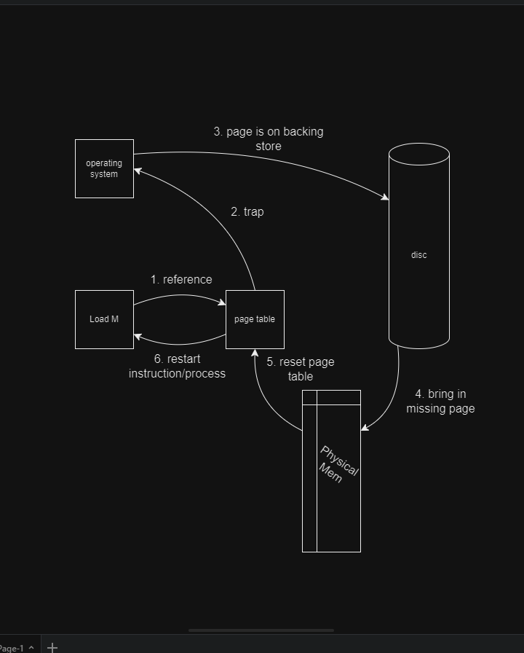

# Separation of Policy

The separation of mechanism and policy is a design principle that says that mechanisms (parts of a system) should not restrict the policies that control the operations and way resources are allocated. A memory management system is divided into three parts: a low-level MMU handler, a page fault handler, and an external pager which runs in the user space. How the MMU works is encapsulated in the MMU handler (which is machine dependent code). The page fault handler is a machine-independent code and contains the mechanisms for paging. Lastly, the policy is determined by the external pager that runs the user’s process.

# Memory Management Program Screenshot

**How it Works:** First, we prompt the user for the page size (either 4095 or 8191 bytes). From there, we get the page size in binary and hexadecimal, initialize the page table, prompt the user for a hexadecimal virtual address, and then convert said address into the physical address. Last step, we check to see if that address fits or if it is currently on the disc and print the result to the user.